Synergies and Exploratory Procedures for Haptic Object Recognition

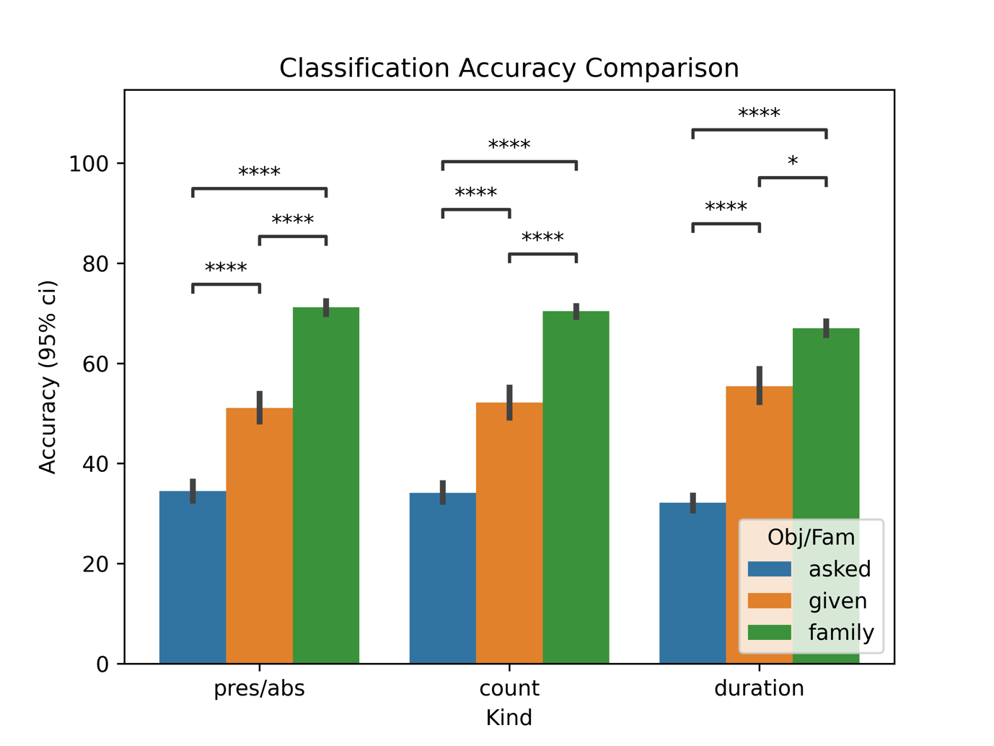

**Figure 1.** This figure depicts the classification accuracy for different classifiers. These classifiers are based on different inputs (the presence or absence of a particular Exploratory Procedure, the number of times each EP appears in a trial or the time spent on each EP) and target variables (the object we gave to the subject in that trial, the object we asked for and the family for that trial). We cannot appreciate any difference in the classification accuracy with respect to the input used. These results show significantly different accuracies for different target variables. We can see the EPs used are strongly related to the family (~70% accuracy with a chance level of 20%) as expected from previous work by Lederman & Klatzky [1]. We can also see a difference in accuracies between the *asked object* and the *given object* as target variables (with ~50% and ~33% accuracies respectively with a chance level of 33%). These results suggest that the selection of EPs is primarily guided by the perceived properties of the object being manipulated rather than the object they are asked about.

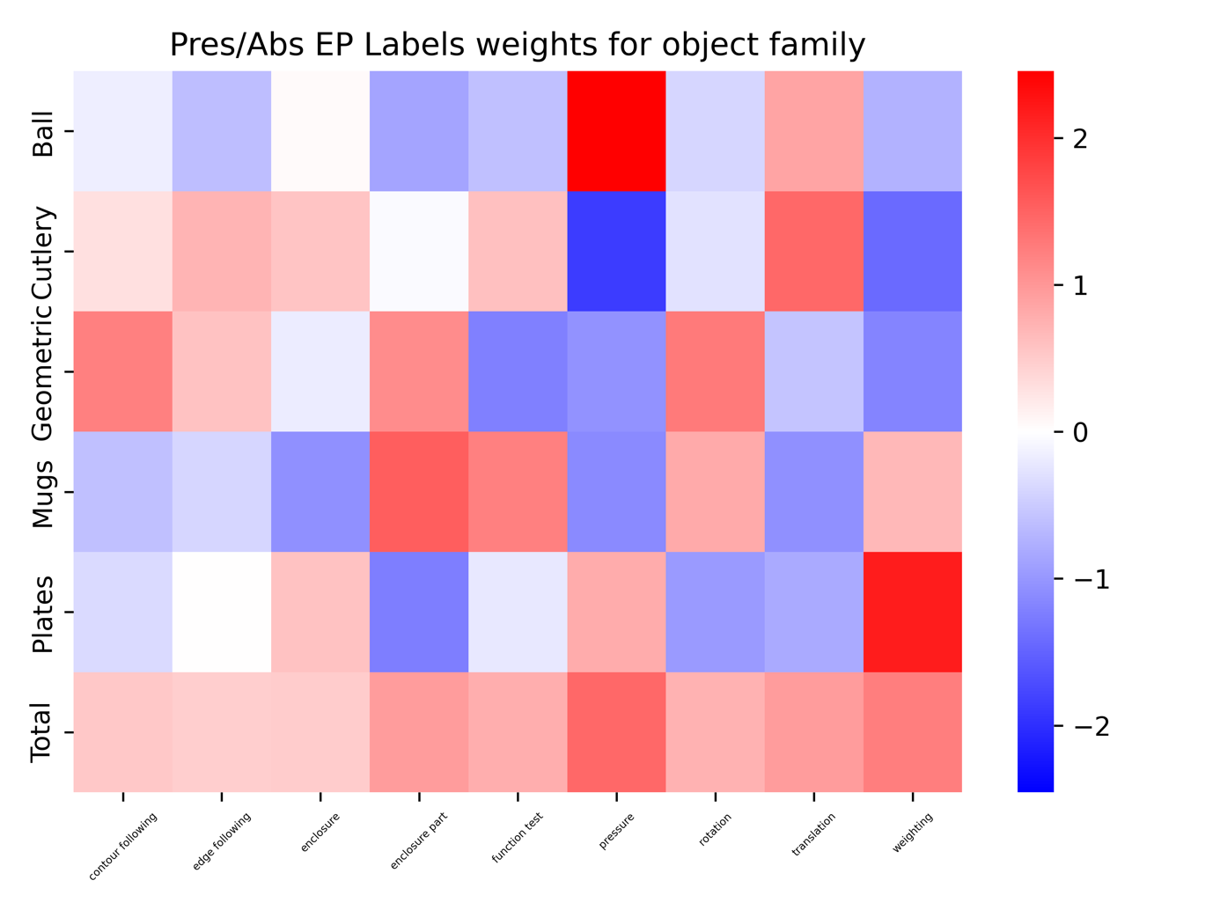

**Figure 2.** This figure shows the weights associated to each variable (EPs in our case) built to predict the object’s family based on the presence or absence of the EPs**.** The *total* row is computed as the mean of the absolute values for each family. Positive weights cause the model to categorize a trial as belonging to a specific family when the corresponding EP is present, whereas negative weights result in the model classifying the trial as not belonging to that family when the EP is present. The absolute value of the weight denotes the impact that the respective EP has on the final classification. E.g.: Those trials with the EP *pressure* won’t be classified as *mugs, geometric* or *cutlery* but as *plates* or more probably, as *sports balls*. This is a numerical approach to the results previously reported by Lederman & Klatzky [1].



**Figure 3.** The reconstruction error from each model applied to all data splits.



**Figure 4.** The result of the mapping of the synergies of subject 2 on the syn-  
ergies of subject 1. The synergies of subject 2 which have the highest (lowest)  
correlation are mapped and visualized together. Correlation allows to detect  
anti-correlated pairs which are shown in green.

**Figure 5.** Similarity calculated using three different metrics. **(a)** Shows the correlation between every synergy of subject 1 with every synergy of subject 2. **(b)** Visualizes the best match between the synergies extracted form subject 2 towards subject 1. The marker size indicates the correlation/distance.

**Figure 6.** This figure shows the classification accuracy targeting the EP label using the raw data, the scores form the synergies extracted from all subjects together and the scores from synergies leaving one subject out. Results suggest that there are underlying patterns between subjects even though they are not fully shared.

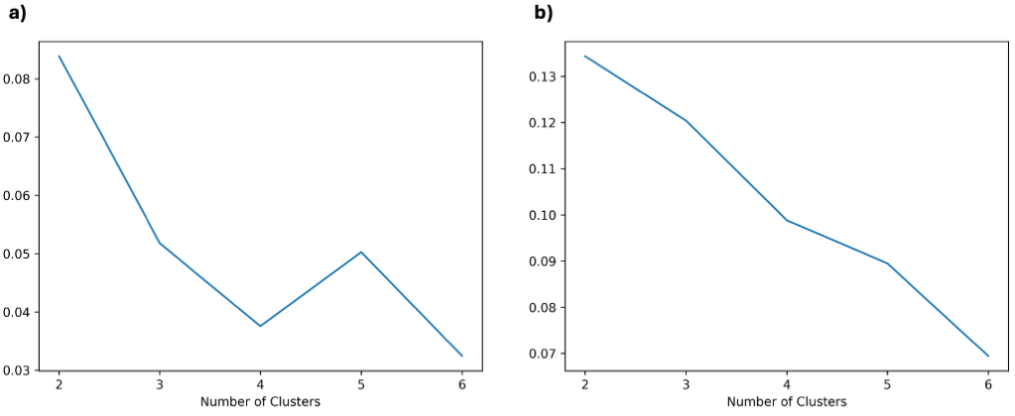

**Figure 7.** This figure shows the silhouette score resulting after clustering the synergies extracted from each subject **(a)**  and EP **(b)**. Scores for subject clustering are very low and at every step the algorithm creates a new cluster for a single subject. Score for EPs are higher and show very interesing results for two clusters, dividing the EPs in what can be considered coarse and fine movements.

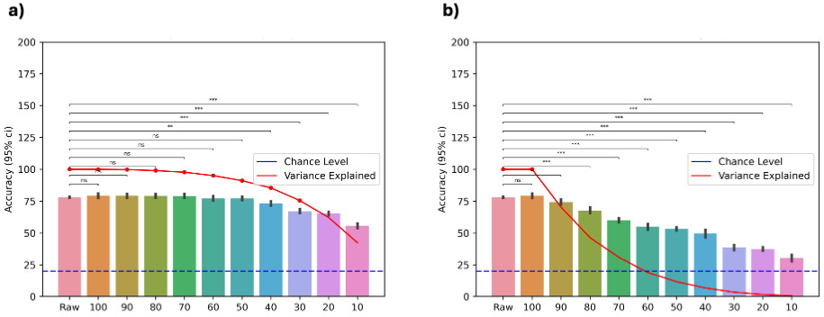

**Figure 8.** This figure depicts the evolution in classification accuracy as we discard synergies compared to the accuracy for the classifier using the raw data. All results correspond to classifiers based on kinematic data for predicting the family object. X axis corresponds to the percentage of synergies used for that result. Y axis shows classification accuracy (95% c.i.) and variance explained. Figure **(a)** shows the accuracy evolution while discarding the less relevant synergies. As we can see, the classification accuracy remains quite consistent until we only keep the 40% of the original synergies and accuracy is still above chance levelswhen keeping only th most relevant 10%. Figure **(b)** correponds to the results discarding the most relevant synergies. Even the accuracy drops significantly after discarding just the most relevant 10% the accuracy remains above chance even with the less relevant 10% (accounting for almost 0% of the original variance). Both results suggest that even the less relevant synergies contain information that can be used by the classifier.

**Figure 9.** Absolute values for synergy scores for the higher and lower order synergies compared between fine and coarse EPs (as defined previously). Expected results (according to *Yan et al.* [2]) would be to have higher scores (higher recruitment) of low order synergies during coarse EPs while having higher recruitment of high order synergies during fine EPs. As it can be seen, results for synergies 1 and 3 suggest that this approach is not correct.

[1] R. L. Klatzky and S. J. Lederman, “The intelligent hand,” *Psychol. Learn. Motiv.*, vol. 21, pp. 121–151, 1987, doi: https://doi.org/10.1016/S0079-7421(08)60027-4.

[2] Y. Yan, J. M. Goodman, D. D. Moore, S. A. Solla, and S. J. Bensmaia, “Unexpected complexity of everyday manual behaviors,” *Nat. Commun.*, vol. 11, no. 1, pp. 1–8, 2020, doi: 10.1038/s41467-020-17404-0.